Target Posting Date:  (To be completed by Content Marketing Team) | October 13
Author’s Name and Job Title:  (3 authors max) | Authors: Amit Gupta Jenna RoeringShobhit Gupta
Author’s Bio:
(Provided by submitter. Maximum of 100 words)
Author’s Photo:
(Provided as image file (NOT screenshot) by submitter. Maximum file size 50MB)
ALL required media (images, videos, GIFs, tables, etc):  The requesting party (PM, in most cases) must provide image files (NOT screenshot) and video files. The image file size should not exceed < 1MB. | Uploaded to wrike
SEO Title and Description  (SEO Team to complete)  (NOTES: Use the SEO Description in the Basic properties tab; it will also be the description on the post’s “card” for the blog home page. SEO title also becomes the browser tab text) | Title: Extending Snowflake Data Sharing to Open Table Formats  Description: Snowflake extends its zero-ETL data sharing to open table formats, allowing you to securely share Apache Iceberg and Delta Lake tables across clouds and regions
Live URL (use as Name in AEM):  (SEO Team to complete) | /data-sharing-open-table-formats/  https://www.snowflake.com/en/blog/data-sharing-open-table-formats/
Time to Read:  (Total word count divided by 200 = # min needed to read) | 6
Related Blogs (Just For You sidebar)
(max. of 2 posts. Please provide blog titles with URLs hyperlinked. To be completed by Content Marketing Team but suggestions welcomed)
Category Tags:  (To be completed by Content Marketing Team) | Primary: Product & Technology  Secondary: Apps & Collaboration, Data Engineering
Keywords:  (SEO Team to complete) | snowflake data sharing, open table formats, apache iceberg, delta lake, zero-etl, cross-cloud data sharing, data collaboration, horizon catalog, secure data sharing
CTA Recommendation  (SEO Team to complete)  (Content Marketing Team: Use Button Component with asset title or abbreviated title and action copy like Download Now, Read Now, Get the ebook etc.  Character count for buttons is 40 and should be sentence case) | https://www.snowflake.com/resource/the-essential-guide-to-data-sharing/?utm_cta=website-blog-data-sharing-open-formats-guide-data-sharing-ebk

*Note for legal: Some of the messaging and visuals for this blog have already been reviewed ahead of DE Connect.

Extending Snowflake Data Sharing to Open Table Formats
We're excited to announce a major expansion of Snowflake’s zero-ETL data sharing: Now, you can easily and securely share open table formats, including Apache Iceberg and Delta Lake, across regions and clouds. This release allows source providers to securely share data stored in open table formats across any cloud and region without complex pipelines and without incurring exponential per-query egress charges.

Snowflake data sharing already leads in the market when it comes to collaboration capabilities and adoption. With 2.5x the data sharing ecosystem compared to leading competitors, Snowflake collaboration provides increasing value to a growing, global user base. With thousands of customers already sharing data, businesses can use open table format sharing to get the best of both worlds: open-format data sharing and all of the core benefits of Snowflake sharing. These benefits include:

- Near real-time data access
- Snowflake Horizon Catalog’s policy-based governance controls for shared data
- Cross-Cloud Auto-Fulfillment and Egress Cost Optimizer for simplified and economical cross-region and cross-cloud sharing
- Delivery into regulated regions including the U.S. government cloud and Virtual Private Snowflake

Why is this important?
For many years, Snowflake customers have been able to securely share data and collaborate with a vast ecosystem of customers and partners. Data sharing is a cornerstone of the Snowflake platform, with many customers using it to develop connections and build strong data ecosystems in the Snowflake AI Data Cloud.

With the introduction of open table format sharing, Snowflake collaboration capabilities have expanded to:
- Data stored outside of Snowflake in customers' own cloud storage (AWS S3, Azure Storage, Google GCS)
- Data in open table formats, including:
  - Apache Iceberg managed by Horizon Catalog or managed by external catalogs (AWS Glue, Apache Polaris)
  - Delta Lake managed by external catalogs (Databricks Unity, Hive Metastore)

This means businesses that choose open table formats are also now connected into the AI Data Cloud and can enjoy the benefits of a thriving data ecosystem.

What challenge does this solve?
Most organizations frequently need to share diverse data formats, both internally and externally, yet they often encounter obstacles such as:
- Security and compliance: Enforcing fine-grained data-access policies on shared data is crucial for maintaining security and compliance.
- Geographic and cloud dispersion: Collaboration among business units (LOBs, vendors, customers) that are often spread across different regions and clouds, including commercial and government cloud environments.
- Varied data formats: Data exists in diverse formats, such as Apache Iceberg and Delta Lake.
Snowflake data sharing, and specifically open table format sharing, directly addresses the key obstacles that data engineers and data architects face when collaborating on data. It reduces geographic and cloud barriers with the ability to share open-format tables, it extends core governance capabilities, and it gives customers the flexibility to standardize on a data format such as Iceberg, all while allowing global organizations to share with any business unit, vendor and/or customer.

How does it work?
Open table format sharing is enabled by Cross-Cloud Auto-Fulfillment (supported on commercial, Virtual Private Snowflake and U.S. government clouds), which simplifies data sharing for Apache Iceberg and Delta Lake directly from your cloud storage. You can share this data with a Snowflake consumer in any region or cloud without needing to manage the underlying infrastructure or requiring you to maintain extract, transform and load (ETL) jobs. In addition, open table format sharing optimizes data transfer costs through Egress Cost Optimizer, helping to avoid unpredictable and astronomical per-query egress charges.

Snowflake Horizon Catalog provides comprehensive policy-based governance controls that can be applied to open table format data shared with consumers across different regions or clouds. This capability ensures data residency and facilitates the compliance necessary for collaboration, particularly within or in conjunction with regulated sectors, such as public sectors, financial services, healthcare and life sciences.

When combined with Delta Direct and Catalog Federation (leveraging Unity Catalog and Uniform's IRC API), Snowflake Cross-Cloud Auto-Fulfillment extends this capability to a Delta Lake table residing in your cloud storage and written by Delta engines such as Microsoft Fabric or Databricks or managed by catalogs such as Databricks Unity or Hive Metastore. This extends open table sharing to Delta Lake tables with Snowflake consumers in any region or cloud, again, without the need to manage underlying infrastructure.
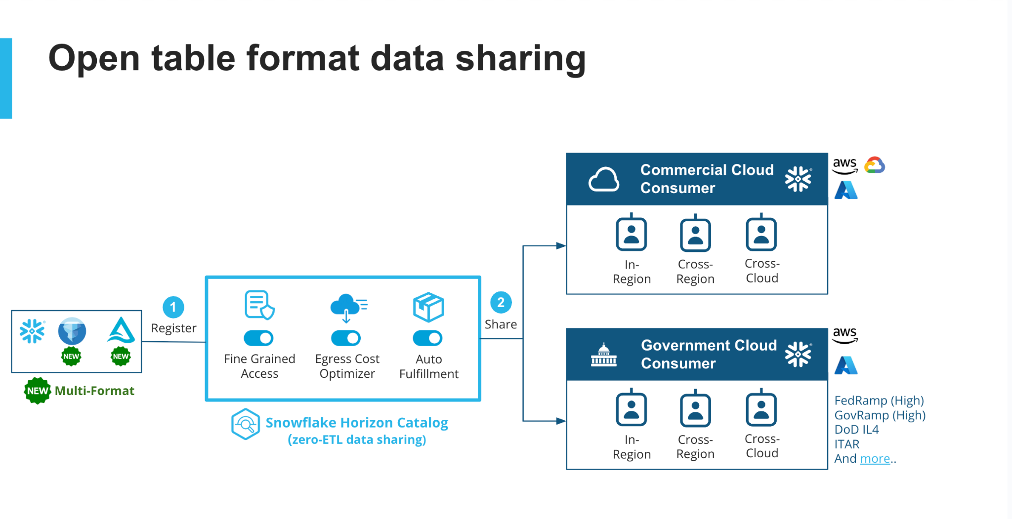
(Editable visuals here)

Example of sharing managed Apache IcebergTM tables on Snowflake

Open table format sharing allows Apache Iceberg and Delta Lake tables to be shared across regions or clouds and is available only through the Iceberg Cross-Cloud Auto-Fulfillment feature. For details on how auto-fulfillment works, see “Auto-fulfillment for listings.” For more information on how open table format sharing works, see the “Using auto-fulfillment with open format tables” documentation.

Here is how to get started with sharing open table formats, using the example of sharing Iceberg tables.

Step 1: Create a table with an open table format (for instance, Iceberg)
Sign in to the provider account and create an open table format (such as Iceberg) following the SQL commands listed below. For more information on how to create Iceberg tables or managed by external catalogs, see the CREATE ICEBERG TABLE documentation here.

SQL command for creating an Iceberg table in AWS S3

create database sample_db_laf_<your alias>;
create schema sample_sc;
create warehouse xsmall;
use warehouse xsmall;

-- Create an external volume for managed table
create or replace external volume managed_exvol
STORAGE_LOCATIONS = (
(
NAME = 'my-s3-us-west-2'
STORAGE_PROVIDER = 'S3'
STORAGE_BASE_URL = 's3://datalake-storage-team/iceberg/table_replication_west'
STORAGE_AWS_ROLE_ARN = 'arn:aws:iam::631484165566:role/datalake-storage-integration-role-2'
)
);

-- create iceberg managed table
create or replace iceberg table sample_iceberg_table_for_laf_testing (
symbol string,
description string
) EXTERNAL_VOLUME = 'managed_exvol'
catalog=snowflake
BASE_LOCATION='sample_iceberg_table_for_laf_testing';

insert into sample_iceberg_table_for_laf_testing values ('A', 'Adam'), ('E', 'Eve'), ('B', 'Bob');
insert into sample_iceberg_table_for_laf_testing values ('D', 'Dan'), ('C', 'Cat'), ('F', 'Fan');

select * from sample_iceberg_table_for_laf_testing;


Step 1b (optional): Protect data with policy-based governance controls

Before sharing, leverage Snowflake Horizon Catalog’s governance features’ full support on your Horizon-managed and externally managed Apache Iceberg or Delta tables, including:
- Fine-grained governance policies: row access, masking policies
- Privacy-enhancing policies: aggregation policy, join policy, projection policy
- Data classification and tagging
- Generation of descriptions using Snowflake Cortex AI

Additionally, you can audit and monitor the sharing with a complete audit using account usage and access history.

For more information, review examples in “Share data protected by policy.”

Step 2: Create a listing targeting consumers within/across regions with a few clicks
In your provider account, create a private listing through Snowsight interface by clicking +Listing and selecting Only Specified Customers, then doing the following:
- Specify a listing name
- Attach the Iceberg table that you created
- Add a listing description
- Specify the account alias of the consumer account
- Publish the listing

Detailed steps are available here.

Status: Using the ACCOUNTADMIN role, you can check the status of the listing in the provider account by going to Data Sharing -> Provider Studio -> Listings.

Cross-Cloud Auto-Fulfillment ensures that your data is securely and automatically delivered to consumers across any region or cloud.

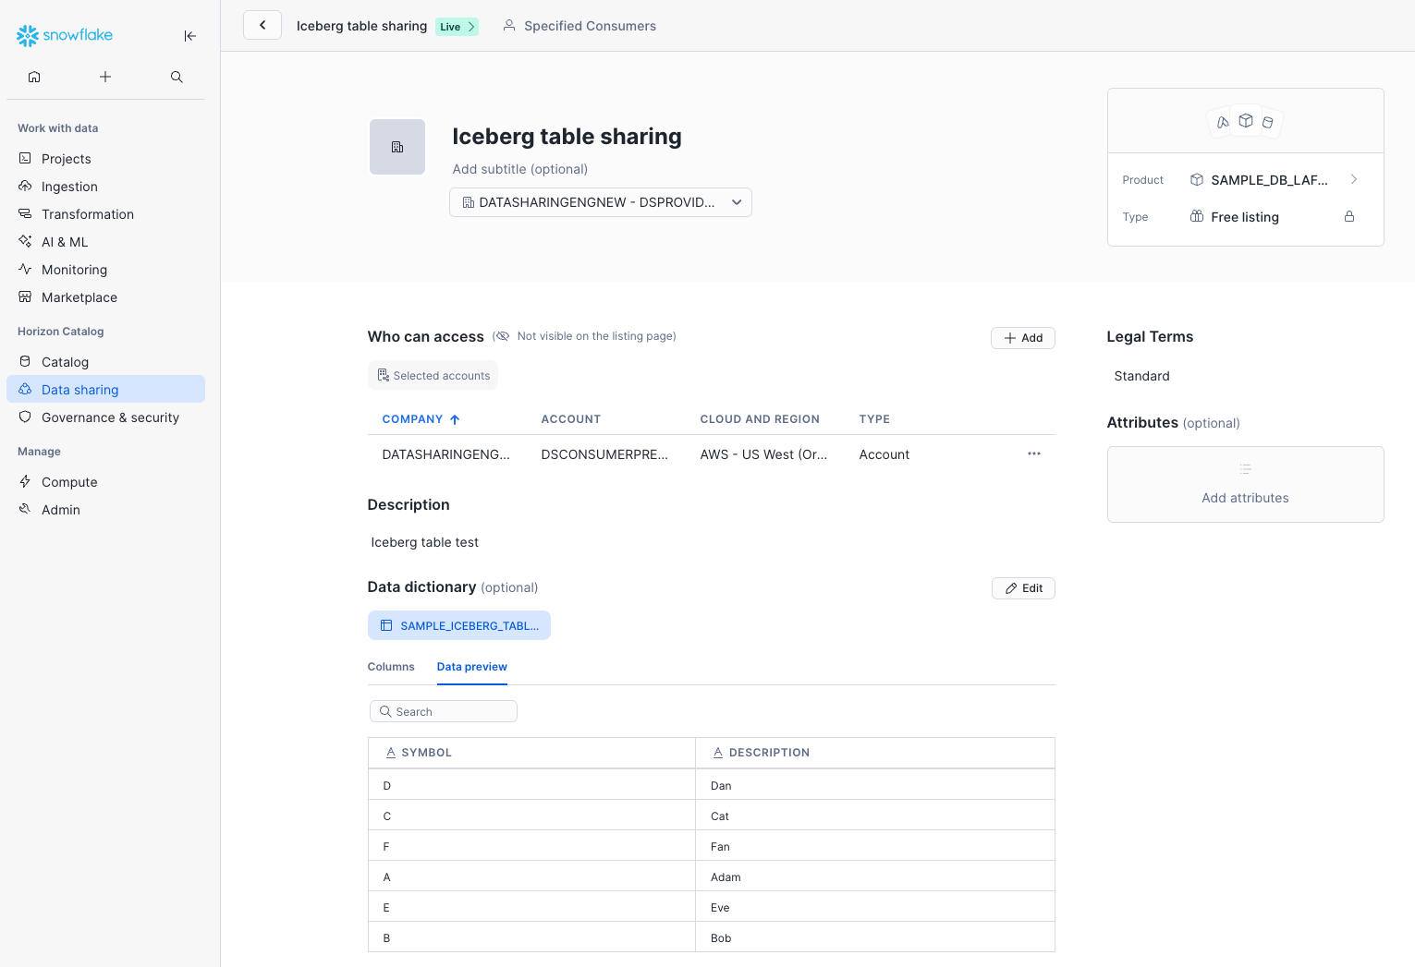

Step 3: Consumers within or across organizations can access your listing
Consumers can go to Data Products -> Private Sharing to find the private listing, and then click Get. The consumer can be within the same account (internal sharing), within the same organization (internal marketplace), or across organizations (external sharing on Snowflake Marketplace).

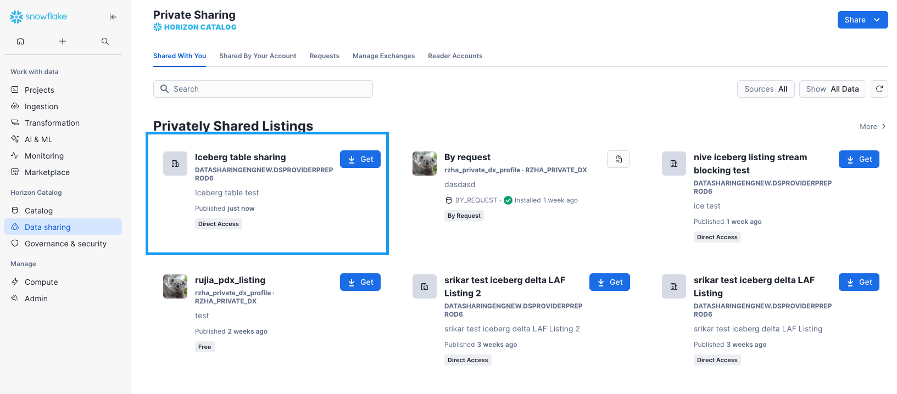

Wrapping up
Snowflake is extending its zero-ETL data-sharing leadership by integrating open table formats to enable secure, governed and cost-optimized data sharing across any cloud and region. To see these powerful new capabilities in action and learn how to get started, check out this solutions page featuring a demo and quickstart!

